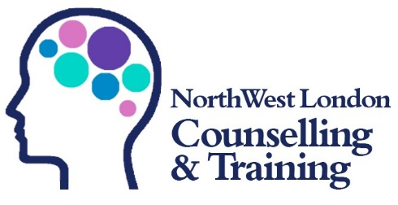

Application form for Certificate in Counselling Skills (CSKL2)

Personal information

Name*: First Name Middle name(s) Surname

* Please use the name that you wish us to register you with CPCAB as. This must be the name that you use on your official documents

Telephone: Telephone number

Address: Address line 2
Address line 2
City
Postcode

Email address: Email address

Date of Birth: DD/MM/YYYY

Date and time of course being applied for: Please tell us which course you are applying to

Application questions

- Please tell us a little about yourself:
Please tell us a little about yourself

- What was your last learning experience like?
What was your last learning experience like?

- What do you want to get from this course? (Apart from the Certificate).
Please tell us a little about yourself

- What do you already know about counselling?
Please tell us a little about yourself
- Do you have access to a private room that you can study in?
Please let us about your learning environment

- Do you have any major life changes or plans to make major life changes coming up?
If yes, please tell us a little more – this will help us to plan for your learning needs:

- Are you able to access technology to attend classes online?
Are you able to access technology to attend classes online?

- Are you able to print documents to compile a hard copy folder of your work over the course?
Are you able to print documents to compile a hard copy folder of your work over the course?

- Are you related to anyone who is currently studying or planning to study with NWLCT?
Are you related to anyone who is currently studying or planning to study with NWLCT?

Entry Guidance

Potential candidates must possess a level of literacy and numeracy sufficient for the programme concerned and be aware of the time and other resources required for the course.

Applicants need to know that this course is not suitable for those who are currently in a state of severe emotional difficulty and/ or severe psychological confusion, for example those;

- Currently experiencing – without ongoing and appropriate professional support – a recent, major life crisis such as a marital breakdown or close bereavement

- Currently experiencing moderate to severe mental health problems including, for example, clinical depression, severe anxiety disorders, eating disorders, personality disorders or any form of psychosis

- Currently involved in substance misuse

This course involves experiential elements that will involve some personal disclosure and associated personal development activities.

By applying for this course and signing below you accept your understanding and agreement to the above:

Signed: Please sign here

Consent:

I consent to the electronic storage of this information in accordance with the Data Protection Act for the purpose of evaluating North West London Counselling & Training learning and support services.
Signed: Please sign here
Date: Click or tap to enter a date.

Equal opportunities monitoring form

Ethnic origin
Asian / Asian British
☐ Indian
☐ Pakistani
☐ Bangladeshi
☐ Other

Mixed
☐ White and Black Caribbean
☐ White and Black African
☐ White and Asian
☐ Any other mixed background

Other
☐ Any other
White
☐ British
☐ Irish
☐ Other

Black / Black British
☐ Caribbean
☐ African
☐ Other

Chinese / Chinese British
☐ Chinese
☐ Other

Gender

☐ Male ☐ Female ☐ Non-binary ☐ Prefer not to say

Disability

Do you class yourself as having a disability?

☐ Yes ☐ No

Do you class yourself as having a learning difficulty?

☐ Yes ☐ No

Is there any extra support that we can give you?

Is there any extra support that we can give you?

Where did you hear about the course?

Where did you hear about the course?

